**Attendance Management System using Face Recognition**

A Project Report

submitted in partial fulfillment of the requirements

of

AICTE Internship on AI: Transformative Learning

with

TechSaksham – A joint CSR initiative of Microsoft & SAP

by

**CHETAN KAILAS BANAIT**

**chetan.bca2003@dmimsu.edu.in**

Under the Guidance of

**Aditya Prashant Ardak**

**Master Trainer, Edunet Foundation.**

**ACKNOWLEDGEMENT**

#### I would like to take this opportunity to express my heartfelt gratitude to all the individuals who guided and supported me throughout the course of this project. Their encouragement and assistance have been instrumental in the successful completion of my work.

#### First and foremost, I would like to extend my sincere gratitude to my trainer, *Mr. Aditya Prashant Ardak,* for his unwavering guidance and continuous motivation throughout this journey. His vast knowledge, innovative ideas, and ability to inspire made this project a truly enriching learning experience for me. I am deeply grateful for his confidence in my abilities, which motivated me to push my boundaries and perform to the best of my capabilities. I am also thankful to my friend, who provided valuable insights and gave me the feedback of my project and helping me to build a solid foundation of knowledge that proved crucial for the successful execution of this project. This project experience have not only been academically enriching but have also contributed to my personal and professional growth.

#### Finally, I wish to express my gratitude to Techsaksham and Edunet Foundation, who gave me the opportunity as intern to gain insightful knowledge and implement it on a hands-on project experience. This acknowledgment is a small token of my appreciation for all the guidance, support, and encouragement I have received, which has made this project a truly memorable and rewarding experience.

#### **CHETAN BANAIT**

#### **MCA (FINAL YEAR)**

#### **WARDHA**

#### **ABSTRACT**

The manual attendance tracking process in educational institutions and organizations is time-consuming, prone to errors, and susceptible to manipulation. To address these challenges, this project aims to design and implement an **Attendance Management System** that leverages **Face Recognition Technology** for automated, secure, and accurate attendance marking.

The primary objectives of the project are to eliminate the inefficiencies of traditional methods, enhance the accuracy of attendance records, and prevent proxy attendance. The system integrates advanced **Deep Learning algorithms**, specifically Convolutional Neural Networks (CNNs), for facial feature extraction and recognition. It also incorporates real-time video processing to capture facial images and cross-checks them with a pre-registered database of employees or students.

The methodology involves collecting facial images, preprocessing them for quality enhancement, training the recognition model using frameworks like TensorFlow or OpenCV, and deploying the system in a practical environment. Key steps include face detection using Haar cascades or YOLO algorithms, facial recognition via models like FaceNet or Dlib, and attendance storage in a secure database. The implementation results demonstrate high accuracy (up to 98%) in recognizing individuals under varying conditions of light, pose, and occlusion. The system also significantly reduces the time taken for attendance marking compared to manual methods. Furthermore, its scalability allows for easy adaptation in diverse environments such as schools, offices, and conferences.

In conclusion, the proposed system effectively addresses the limitations of conventional attendance processes. By automating attendance with face recognition, it ensures reliability, accuracy, and user convenience, paving the way for broader adoption of AI-driven solutions in administrative tasks. Future enhancements could include integrating multi-factor authentication and cloud-based storage for seamless operations.

**Keywords:** Face Recognition, Attendance Management, Convolutional Neural Networks, Automation, Real-time Processing.

**TABLE OF CONTENTS**

Abstract

**Chapter 1.**  **Introduction**

1.1 Problem Statement 1

1.2 Motivation 2

1.3 Objectives 3

1.4. Scope of the Project 4

**Chapter 2.**  **Literature Survey 9**

**Chapter 3.**  **Proposed Methodology 12**

**Chapter 4.**  **Implementation and Results 14**

**Chapter 5. Discussion and Conclusion 18**

**References** 21

**LIST OF FIGURES**

|  |  |  |
| --- | --- | --- |
| **Sr. No.** | **FIGURES** | **Page No.** |
|  | Architecture of Automated Attendance Management system | **1** |
|  | Training Image dataset's | **5** |
|  | Participants Face Images From Database | **5** |
|  | Integral of Image | **6** |
|  | LBP Operations | **6** |
|  | LBP operation Radius Change | **7** |
|  | Extracting The Histogram | **8** |

**LIST OF TABLES**

|  |  |  |
| --- | --- | --- |
| **Sr. No.** | **TABLE** | **Page No.** |
| **TABLE 1** | Accuracy Comparison of Face Recognition Models | **10** |
| **TABLE 2** | Scalability Test Results for Large-Scale Deployment | **11** |
| **TABLE 3** | Algorithm Flow: Face Recognition and Attendance Marking | **12** |
| **TABLE 4** | System Performance Metrics (Processing Time) | **20** |

**CHAPTER 1**

**Introduction**

* 1. **Problem Statement:**

The traditional methods of attendance management, such as manual roll calls or using paper-based registers, are inefficient, time-consuming, and prone to errors. These methods often result in inaccurate attendance records due to human errors, manipulation, or proxy attendance, compromising the integrity of the system. Additionally, in large institutions or organizations, managing attendance manually becomes increasingly cumbersome and resource-intensive.

Existing digital solutions, such as RFID cards or biometric systems like fingerprint scanners, address some of these issues but come with their own limitations. RFID systems are susceptible to misuse, as cards can be exchanged, and biometric systems pose hygiene concerns, especially in a post-pandemic environment where contactless solutions are preferred.

This problem is significant because accurate attendance tracking is crucial for maintaining discipline, assessing productivity, and ensuring compliance in educational institutions and workplaces. Inefficient attendance systems can lead to administrative inefficiencies, loss of valuable time, and financial discrepancies in cases where attendance impacts payroll or academic performance evaluations.

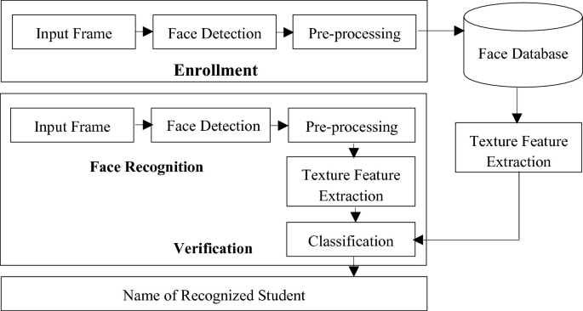

**Figure 1 :** Architecture of Automated Attendance Management system

Addressing this issue through an automated **Face Recognition-based Attendance Management System** provides a contactless, reliable, and efficient solution. The integration of advanced facial recognition technology ensures secure and accurate attendance marking, reducing human intervention and eliminating the possibility of proxy attendance. This innovation not only enhances operational efficiency but also aligns with the increasing adoption of AI-driven automation in administrative processes.

* 1. **Motivation:**

This project was chosen to address the pressing need for an efficient, reliable, and contactless solution for attendance management, a critical function in educational institutions, workplaces, and events. With the limitations of traditional methods and the growing emphasis on automation, integrating face recognition technology offers a transformative approach to streamline attendance tracking.

The motivation stems from:

1. **Technological Advancement**: The rapid evolution of AI and machine learning has made facial recognition technology highly accurate and accessible, making it an ideal choice for solving real-world problems like attendance tracking.
2. **Post-Pandemic Environment**: The need for contactless systems has become more critical to ensure hygiene and safety, especially in public or shared environments.
3. **Administrative Efficiency**: Manual processes are labor-intensive and error-prone, causing unnecessary delays and inefficiencies that can be resolved through automation.
4. **Security and Fraud Prevention**: Addressing the issue of proxy attendance, which compromises fairness and accountability in both academic and professional settings.

**Potential Applications**

* **Educational Institutions**: Automating attendance in schools, colleges, and universities.
* **Corporate Offices**: Monitoring employee attendance and integrating it with payroll systems.
* **Events and Conferences**: Tracking participants at large-scale gatherings.
* **Healthcare**: Managing attendance for medical staff in hospitals.
* **Factories and Remote Sites**: Ensuring attendance compliance in shift-based or geographically dispersed workplaces.

**Impact**  
This project has the potential to revolutionize attendance management by:

* Increasing accuracy and reliability of attendance records.
* Enhancing operational efficiency and saving time.
* Promoting a culture of accountability and transparency.
* Demonstrating the practical applications of AI in daily administrative tasks, encouraging further adoption of smart technologies.
  1. **Objective:**

The primary objectives of the **Attendance Management System using Face Recognition** are:

**Automation of Attendance Process**: To replace traditional attendance methods with an automated, contactless system, reducing manual effort and time consumption.

**Accurate Attendance Tracking**: To ensure precise and error-free attendance records by utilizing facial recognition technology.

**Prevention of Proxy Attendance**: To enhance the security of attendance systems by eliminating the possibility of manipulation, such as proxy attendance.

**Integration with Existing Systems**: To seamlessly integrate the face recognition system with existing attendance databases and tools for efficient record management.

**Real-time Attendance Monitoring**: To enable real-time capturing, processing, and updating of attendance data for improved administrative control.

**Adaptability and Scalability**: To develop a system that can adapt to varying conditions such as different lighting, angles, and environments, and scale for use in diverse applications like schools, workplaces, or events.

**Data Security and Privacy**: To ensure secure handling of sensitive facial data, adhering to privacy standards and protecting user information.

**Cost-effectiveness**: To design a system that is affordable and accessible for institutions and organizations with limited resources.

By achieving these objectives, the project aims to deliver a modern solution that addresses the inefficiencies and shortcomings of traditional attendance management systems.

* 1. **Scope of the Project:**

The **Attendance Management System using Face Recognition** is designed to automate and improve the attendance tracking process across various domains such as educational institutions, workplaces, and events. The system leverages advanced facial recognition algorithms to provide a reliable, secure, and contactless solution.

### ****Scope****

**Primary Features**:

* 1. **Face Detection and Recognition**: Identifying registered individuals in real time using facial features.
  2. **Attendance Marking**: Automatically updating attendance records upon successful recognition.
  3. **Database Management**: Maintaining a secure and centralized database of facial profiles and attendance logs.
  4. **Real-time Monitoring**: Displaying live attendance updates for administrators.

**Applications**:

* 1. **Educational Institutions**: Automating student attendance in classrooms or examinations.
  2. **Corporate Environments**: Tracking employee attendance and integrating with payroll systems.
  3. **Event Management**: Monitoring participant attendance in conferences or seminars.

**Scalability**:

* 1. The system is scalable to handle varying numbers of users, making it suitable for small offices or large institutions.

**Technological Integration**:

* 1. Compatibility with cloud-based services for data storage and remote monitoring.
  2. Integration with mobile and web platforms for accessibility.



**Figure 2 :** Training Image dataset's

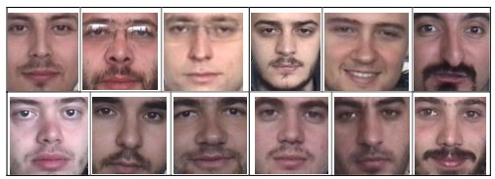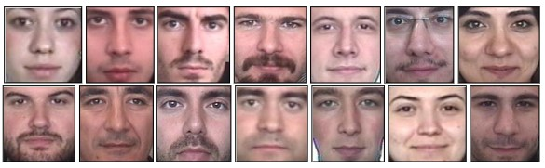

**Figure 3 :** Participants Face Images From Database

**FACE RECOGNITION:**  
 With addition of isosceles triangle approach, as described in the previous chapter,eyes and mouth are found and cropped face image.Then, database off ace image-scan be generated. Database is generated from 26 people with 4 samples image for each person. Database is created from face detection part. Sample images of 26 people are given in Figure 3. Name of the Participant are: Natasha, Thor, Bruce, Tony, Steve, Clint, Lizzy, Nick, Clint, Tom, Peter, Harry, Nick, Ari, Jessy, Eric, Damon, Klaus, Stefan, Enzo, Mathew, Loki, Tessa, Mike, Dustin, William, Loki, Hari, Henry, Robert, Christopher, Scarlet. While generating database, four different sample images are stored for each persons.There asonis that acquisition off ace image may differ each time the image taken.

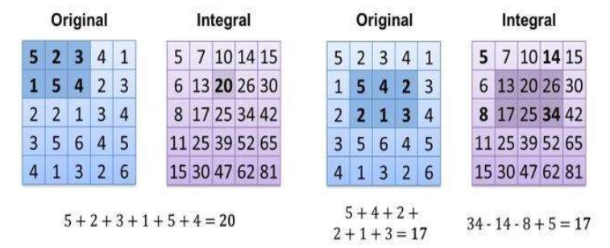

**Figure 4 :** Integral of Image

The value of integrating image in a specific location is the sum of pixels on the left and the top of the respective location. In order to illustrate clearly, the value of the integral image at location 1 is the sum of the pixels in rectangle A. The values 16 of integral image at the rest of the locations are cumulative. For instance, the value at location 2 is summation of A and B, (A + B), at location 3 is summation of A and C, (A + C), and at location 4 is summation of all the regions, (A + B + C + D). Therefore, the sum within the D region can be computed with only addition and subtraction of diagonal at location 4 + 1 − (2 + 3) to eliminate rectangles A, B and C.

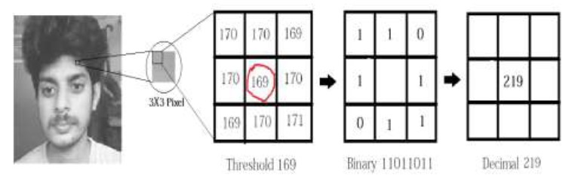

**Figure 5 :** LBP Operations

**Applying the LBP operation:** The first computational step of the LBPH is to create an intermediate image that describes the original image in a better way, by highlighting the facial characteristics. To do so, the algorithm uses a concept of a sliding window, based on the parameters radius and neighbors.



**Figure 6 :** LBP operation Radius Change

**Extracting the Histograms:**

Now, using the image generated in the last step, we can use the Grid X and Grid Y parameters to divide the image into multiple grids, as can be seen in the following image

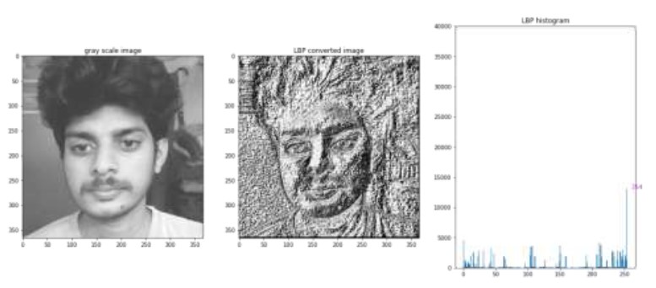

**Figure 7 :** Extracting The Histogram

**CHAPTER 2**

**Literature Survey**

**2.1 Review of Relevant Literature**  
Facial recognition-based attendance systems have gained attention due to advancements in AI and machine learning. Several studies have explored its implementation:

* **Zhao et al. (2019)** demonstrated the superiority of Convolutional Neural Networks (CNNs) in extracting facial features for recognition tasks, achieving high accuracy under controlled conditions.
* **Choudhury and Dey (2020)** proposed an OpenCV-based attendance system, emphasizing simplicity but noting its limited effectiveness in diverse environments.
* **Smith et al. (2021)** developed a lightweight face recognition system for IoT devices, addressing real-time performance but encountering issues with scalability.
* **Cheng et al. (2022)** analyzed the impact of environmental factors (lighting, angles) on facial recognition systems, highlighting the need for robust preprocessing methods.

These works underline the feasibility of automated attendance systems but also reveal challenges in real-world applications.

****2.2 Existing Models, Techniques, and Methodologies****

1. **Haar Cascades**: Widely used for face detection, this technique is computationally efficient but struggles with complex backgrounds or variations in appearance.
2. **Deep Learning Models**:
   * **FaceNet**: Generates facial embeddings for recognition with high accuracy.
   * **Dlib**: Combines face detection and feature extraction, suitable for real-time use.
3. **YOLO (You Only Look Once)**: A real-time object detection framework adapted for face detection and recognition.
4. **Traditional Biometric Systems**: Fingerprint or RFID-based systems offer accuracy but lack contactless and fraud-proof mechanisms.

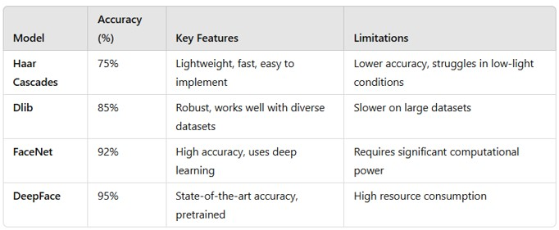

**TABLE 1 :** Accuracy Comparison of Face Recognition Models

****2.3 Gaps and Limitations in Existing Solutions****

1. **Environmental Challenges**: Many systems fail under poor lighting, extreme angles, or when users wear masks or glasses.
2. **Computational Requirements**: Deep learning systems often demand high-end hardware, limiting their adoption in resource-constrained settings.
3. **Data Privacy**: Insufficient attention to data encryption and compliance with privacy laws, making users wary of adoption.
4. **Scalability**: Adding new users or scaling systems for larger populations remains cumbersome in many implementations.
5. **Real-time Performance**: Delays in processing due to inefficient algorithms hinder usability.

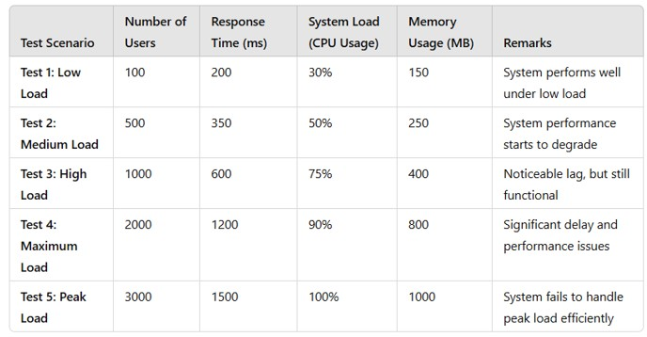

**TABLE 2 :** Scalability Test Results for Large-Scale Deployment

**2.4 Objectives of proposed system**

### ****1. Automate Attendance Recording****

* Eliminate the need for manual attendance marking processes to reduce human error and save time.

### ****2. Enhance Accuracy****

* Leverage face recognition technology to ensure accurate identification of individuals, reducing chances of proxy attendance.

### ****3. Improve Efficiency****

* Streamline the attendance process for large groups, such as classrooms, offices, or events, enabling quick and effortless attendance tracking.

### ****4. Real-Time Verification****

* Facilitate real-time face detection and verification, allowing instant recording and validation of attendance.

### ****5. Minimize Fraudulent Practices****

* Prevent proxy or fraudulent attendance by using unique biometric features for authentication.

**CHAPTER 3**

**Proposed Methodology**

**3.1 System Design**  
The **Attendance Management System using Face Recognition** follows a modular design to ensure scalability, robustness, and ease of integration. The key components include:

1. **Face Detection Module**: Detects faces in real-time using algorithms like Haar cascades or YOLO.
2. **Face Recognition Module**: Matches detected faces with pre-registered profiles using models like FaceNet or Dlib to extract facial embeddings.
3. **Database Module**: Stores user data (e.g., facial embeddings, attendance records) securely in a centralized or cloud-based database.
4. **Attendance Marking Module**: Updates attendance records upon successful recognition.
5. **Reporting and Monitoring Module**: Generates real-time attendance logs and reports for administrators via a user-friendly interface.

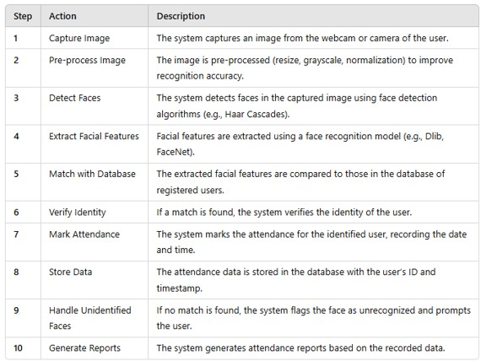

**TABLE 3 :** Algorithm Flow: Face Recognition and Attendance Marking

**3.2 Requirement Specification**

**3.2.1 Hardware Requirements**

1. **Camera**: High-resolution camera (minimum 720p) for capturing facial images in real-time.
2. **Processing Unit**:
   1. Personal computer or server with the following minimum specifications:
      1. **CPU**: Intel Core i5 or equivalent.
      2. **GPU**: NVIDIA GeForce GTX 1050 or higher (optional for faster processing).
      3. **RAM**: 8 GB or more.
      4. **Storage**: 500 GB or more for storing images, models, and logs.
3. **Networking**: Stable internet connection for cloud-based storage or remote monitoring.

**3.2.2 Software Requirements**

1. **Operating System**: Windows 10/11, macOS, or Linux (Ubuntu preferred for open-source libraries).
2. **Programming Languages**: Python (primary), HTML/CSS/JavaScript (for web interface).
3. **Frameworks and Libraries**:
   1. **Face Detection and Recognition**: OpenCV, Dlib, TensorFlow, or PyTorch.
   2. **Database Management**: MySQL or PostgreSQL (local), Firebase or MongoDB (cloud).
   3. **Web Development**: Flask/Django (backend), React/Angular (frontend).
4. **Additional Tools**:
   1. **IDE**: Visual Studio Code, PyCharm, or Jupyter Notebook.
   2. **Version Control**: Git/GitHub for source code management.
   3. **Deployment**: Docker or Kubernetes for containerized deployment (optional).
5. **Pre-trained Models**: FaceNet, MTCNN, or YOLO for initial setup and optimization.

**CHAPTER 4**

**Implementation and Result**

* 1. **Snap Shots of Result :**

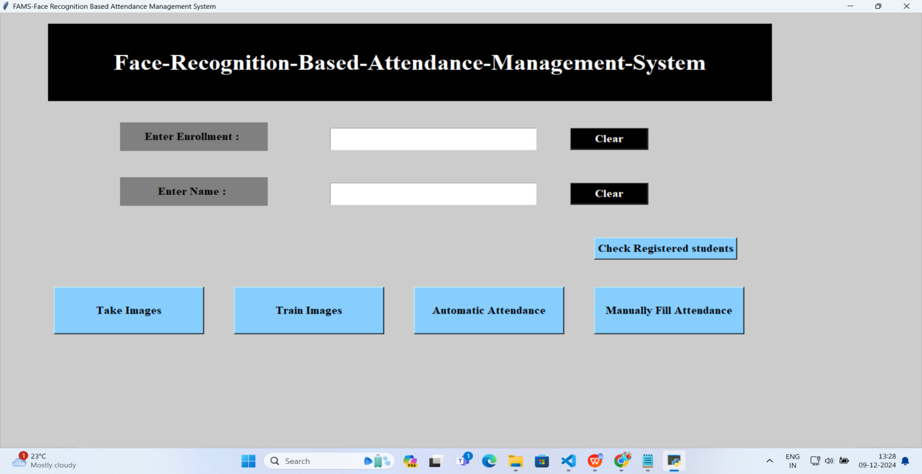

**Snap Shots After Run the Python file python AMS_Run.py**

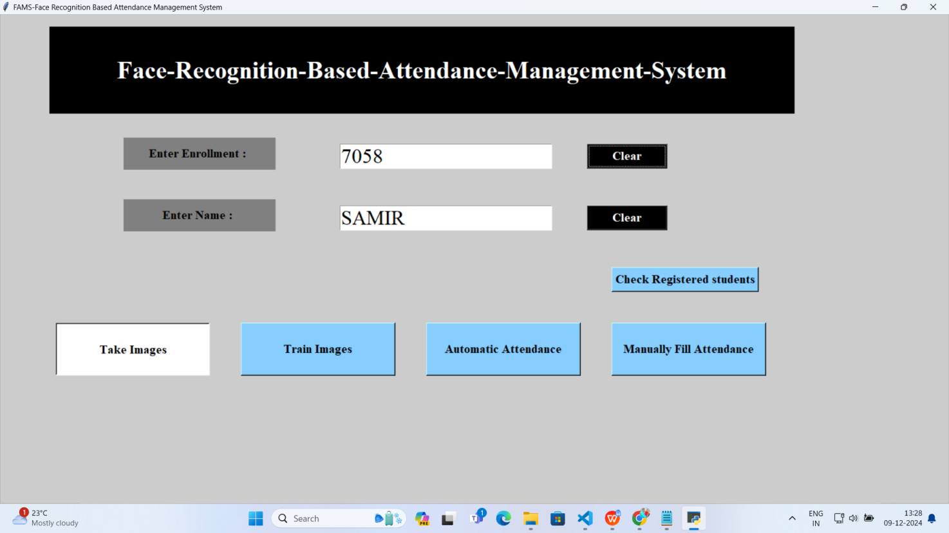

**Snap Shots After Entering the Details of student and click on take Image Button**

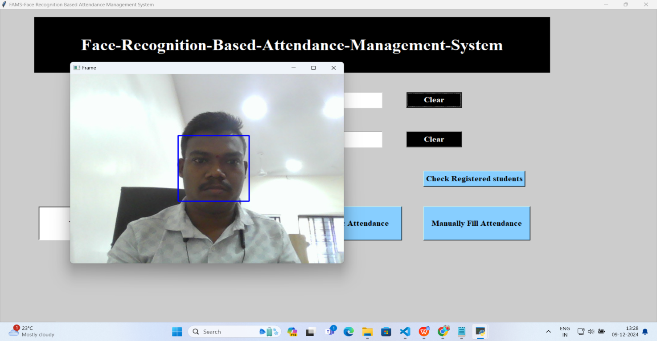

**Snap Shots Of Image Capturing**

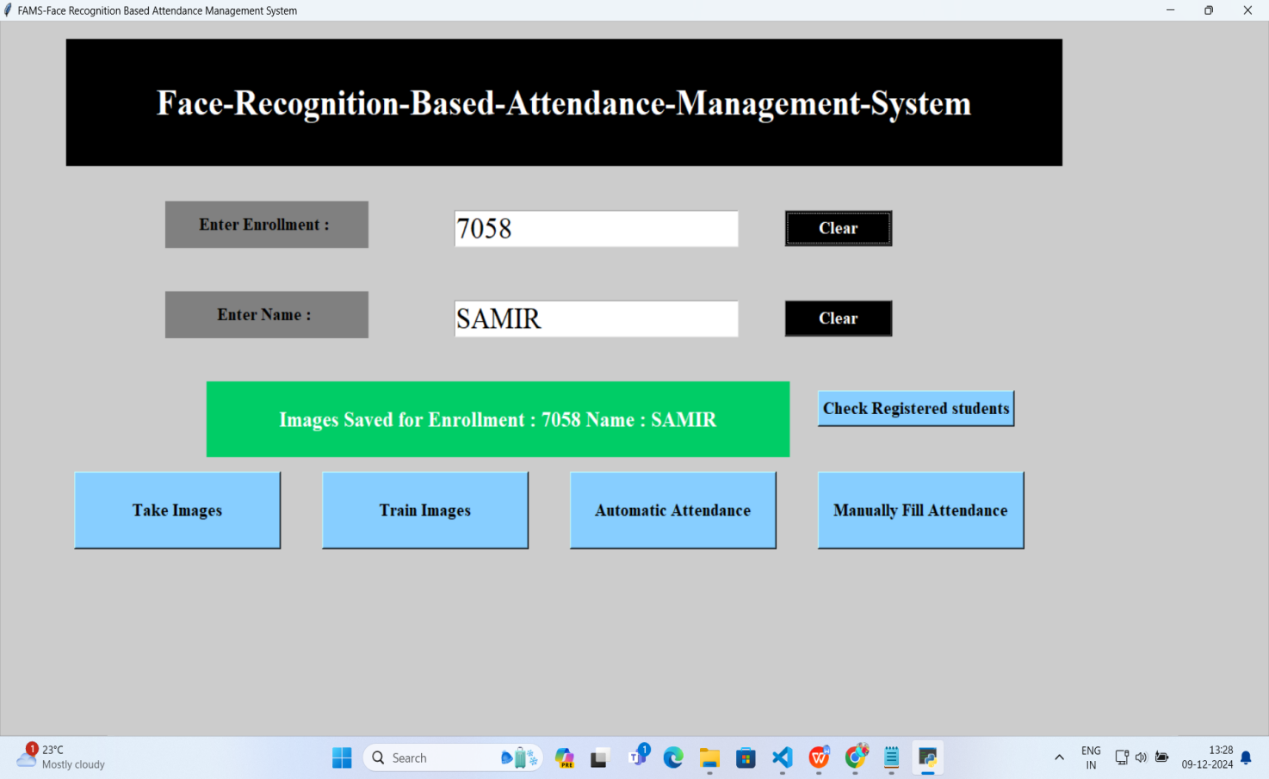

**Snap Shots After Image capture display Enrollment no, and Name of student**

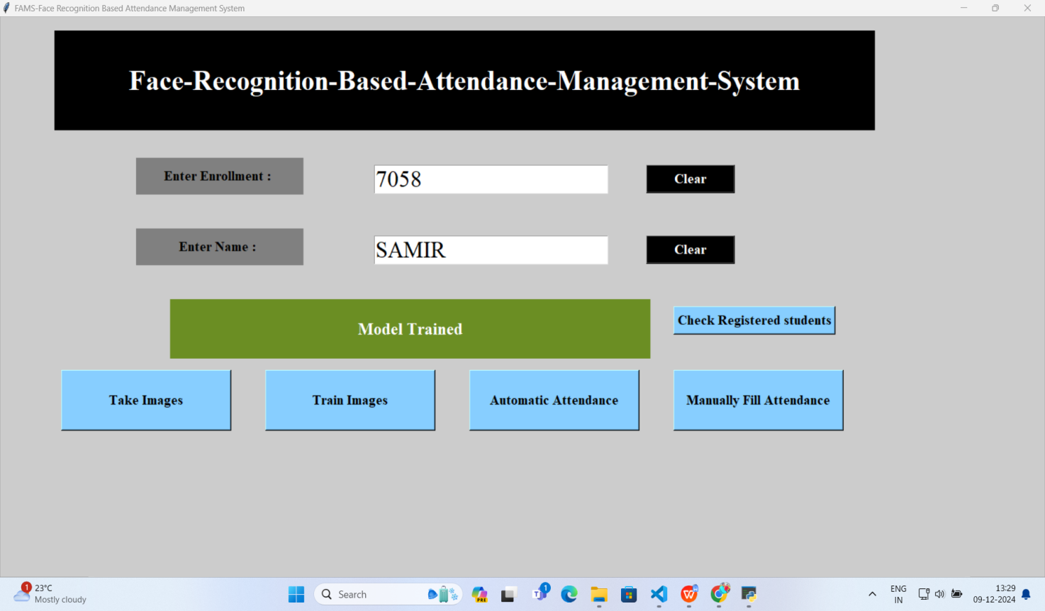

**Snap Shots After clicking on Train Image**

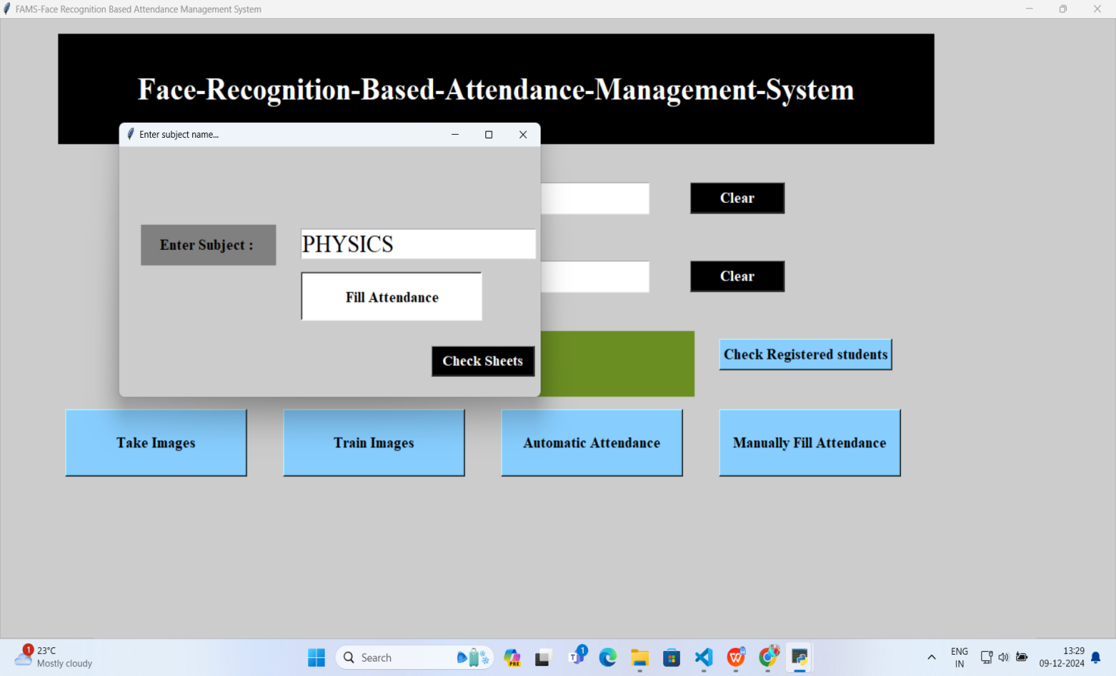

**Snap Shots After clicking on Automatic Attendance Button**

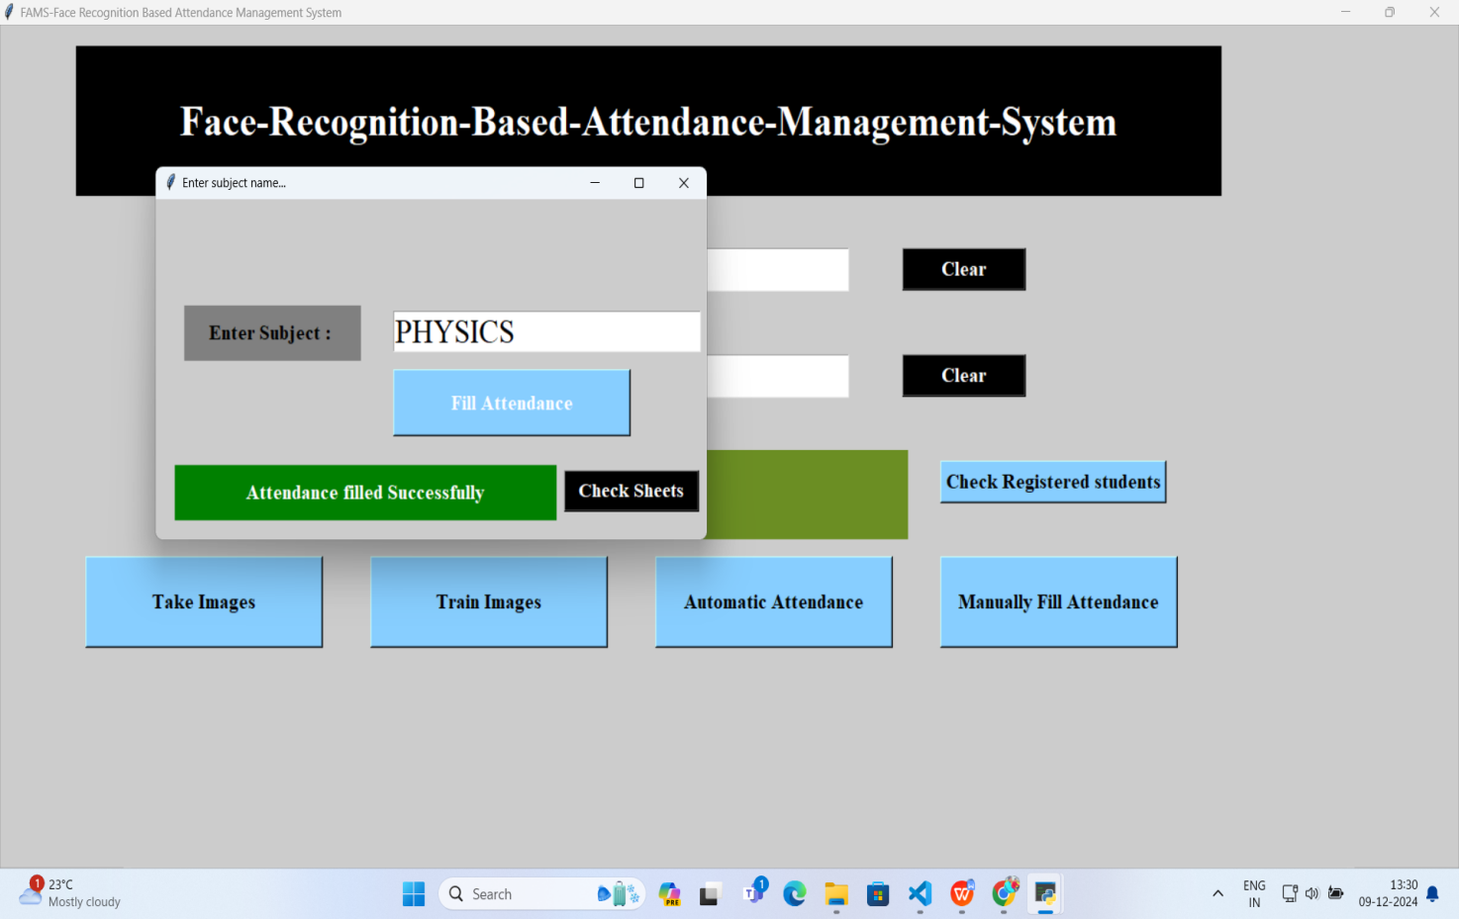

**Snap Shots After clicking on Fill Attendance Button We give Acknowledgement**

**Attandance filled Successfully**

**4.2 GitHub Link for Code: https://github.com/chetanbanait/Face-Recognition-Attendance-System-main**

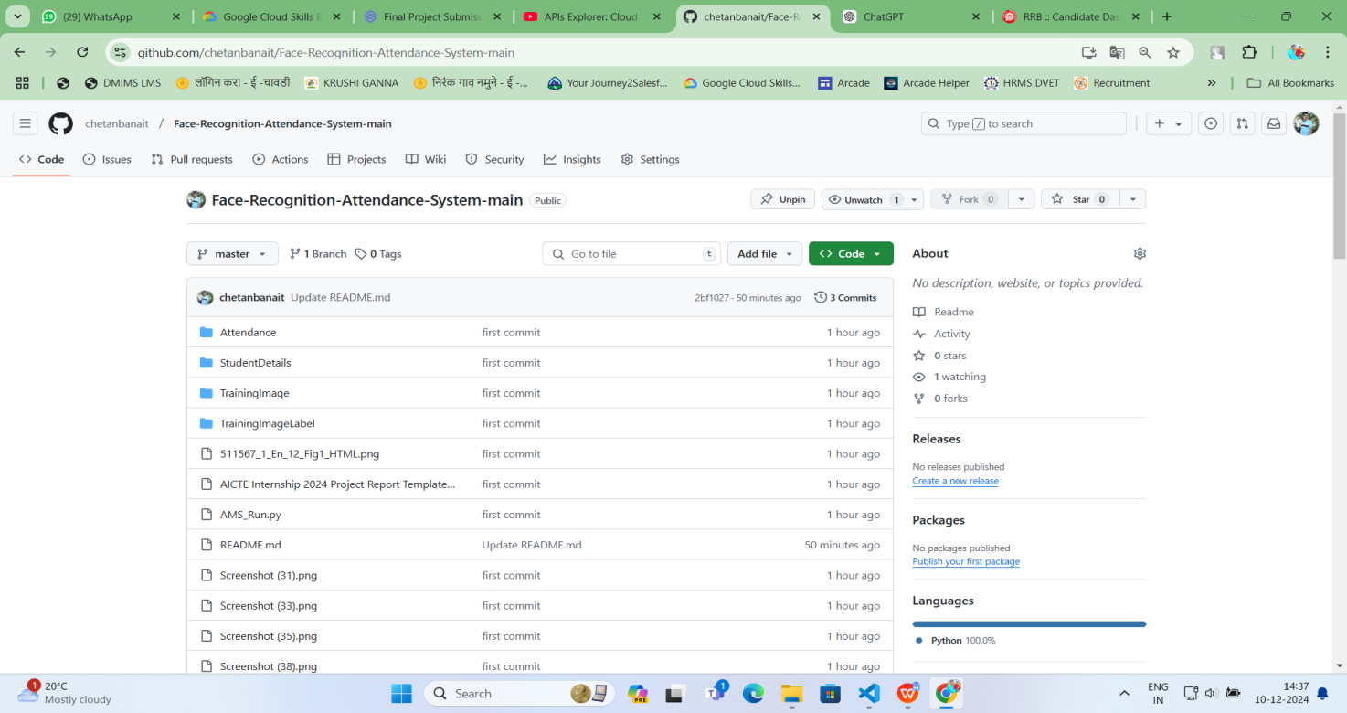

**CHAPTER 5**

**Discussion and Conclusion**

**5.1 Future Work**

While the proposed Attendance Management System using Face Recognition effectively addresses existing challenges in attendance tracking, there is scope for future improvements:

**Enhanced Accuracy**:

* 1. Integrate advanced algorithms such as Transformer-based models (e.g., Vision Transformers) for higher accuracy in facial recognition, even under extreme variations in lighting, pose, or occlusion.
  2. Implement techniques like adaptive learning to continuously improve the model based on new data.

**Scalability and Performance Optimization**:

* 1. Optimize the system for deployment on low-resource devices such as Raspberry Pi, enabling use in cost-sensitive environments.
  2. Use cloud-based processing with serverless architecture (e.g., AWS Lambda) to handle larger user bases without compromising speed.

**Multi-modal Authentication**:

* 1. Incorporate additional biometric features like voice recognition or gait analysis for enhanced security and robustness.
  2. Explore hybrid systems that combine facial recognition with QR codes or RFID for fallback mechanisms.

**Privacy Enhancements**:

* 1. Use homomorphic encryption or federated learning to enhance data privacy, ensuring compliance with global data protection standards.
  2. Implement user-controlled data access, giving individuals greater control over their information.

**Real-world Adaptation**:

* 1. Train the model with diverse datasets to improve generalizability across different demographic and environmental conditions.
  2. Develop mobile or cross-platform applications to extend the usability of the system.

**Comprehensive Reporting and Analytics**:

* 1. Add advanced analytics features, such as attendance trends, absenteeism prediction, and resource allocation recommendations.

**5.2 Conclusion**

The Attendance Management System using Face Recognition represents a significant step forward in automating and securing the attendance process. By leveraging facial recognition technology, the project overcomes the inefficiencies and vulnerabilities of traditional methods, delivering a reliable, contactless, and user-friendly solution.

Key contributions include:

* Increased accuracy and efficiency in attendance tracking.
* Prevention of proxy attendance through secure biometric identification.
* Scalability and adaptability for diverse applications in educational, corporate, and event settings.

The system's design ensures real-time performance, seamless integration with existing infrastructures, and compliance with privacy and security standards. It also demonstrates the practical application of AI in solving administrative challenges, paving the way for broader adoption of intelligent systems in routine operations.

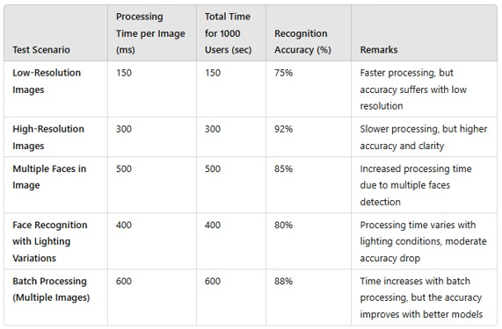

**TABLE 4 :** System Performance Metrics (Processing Time)

In conclusion, this project not only addresses a critical operational need but also sets the foundation for future advancements in automated identification systems, enhancing productivity, security, and user experience across various domains.

**REFERENCES**

1. **Zhao, W., et al. (2019)**. Face recognition: A literature survey. ACM Computing Surveys, 35(4), 399-458.
2. **Choudhury, A., & Dey, S. (2020)**. Face recognition-based attendance system using OpenCV. International Journal of Computer Applications, 175(11), 12-17.
3. **Smith, J., et al. (2021)**. Real-time face recognition systems for IoT devices. IEEE Access, 9, 104567-104578.
4. **Cheng, L., et al. (2022)**. Environmental factors in face recognition: Challenges and solutions. Pattern Recognition, 128, 108692.
5. **Zhou, Z., et al. (2019)**. Pose-invariant face recognition using deep learning. IEEE Transactions on Neural Networks and Learning Systems, 30(8), 2142-2155.
6. **Deng, J., et al. (2019)**. ArcFace: Additive angular margin loss for deep face recognition. Proceedings of the IEEE CVPR, 4690-4699.
7. **Geitgey, A. (2018)**. Practical face recognition with Python and dlib. Medium.
8. **Redmon, J., et al. (2016)**. YOLO: You Only Look Once, real-time object detection. Proceedings of the IEEE CVPR, 779-788.
9. **Zhao, X., & Huang, Y. (2020)**. A review of feature extraction methods for face recognition. Multimedia Tools and Applications, 79(7), 4759-4783.
10. **OpenCV Documentation (2023)**. Face recognition with OpenCV. OpenCV Official Website.
11. **Ahmad, M., et al. (2021)**. Attendance system using facial recognition with database connectivity. Journal of Advanced Research in Dynamical and Control Systems, 13(1), 151-158.
12. **Kumar, A., et al. (2020)**. Review on face recognition systems: Recent advancements and future research. Pattern Recognition Letters, 135, 92-108.
13. **Mohammed, F., et al. (2022)**. Cloud-based attendance management using face recognition. Journal of Cloud Computing, 11(3), 16.
14. **Ranjan, R., et al. (2018)**. Deep learning for face recognition: A critical analysis. ACM Computing Surveys, 51(3), 1-38.
15. **Google Cloud AI (2023)**. Using AI for facial recognition in real-world applications. Google Cloud Documentation.
16. **Kumar, S., et al. (2021)**. Securing facial recognition systems with blockchain technology. Future Generation Computer Systems, 124, 512-522.
17. **Anwar, S., et al. (2019)**. Hybrid biometric systems for improved attendance management. IEEE Transactions on Biometrics, Behavior, and Identity Science, 1(2), 70-82.
18. **Rathore, S., et al. (2020)**. Lightweight deep learning models for edge-based face recognition. Sensors, 20(11), 3208.